1. Project related variables:

**Goal**, **Number of donations**, **Donation amount**, **Creating date**, Duration, Remaining days (if in progress), **Title**, **Number of "updates"**, **Number of "words of support"**, **Category** **(medical, memorial, …),** **Title picture**, **Description (original html format is fine)**

1. **Donator related variables**

**Name, Donation amount, Time**

**Capture as many as donators for each project. You can order the list by top donations.**

1. Organizer and Beneficiary (if any) related variables

Name, Location, previous raising amount and number of donations (if any), type (organizer or beneficiary)

Note there might be more than one organizer, e.g.:

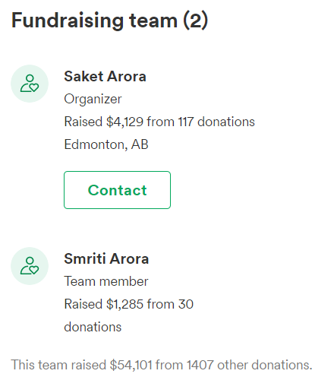 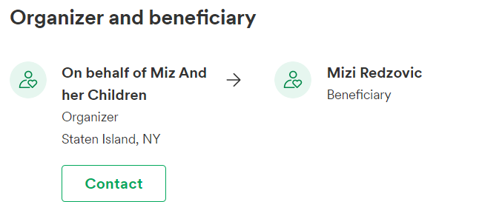

If it’s not difficult to capture, please also include the update and the support information (low priority):

1. **“Updates” information**

**Name, Role, Time, Text**

1. **“Words of support” information**

**Name, Donation amount, Time, Text**